

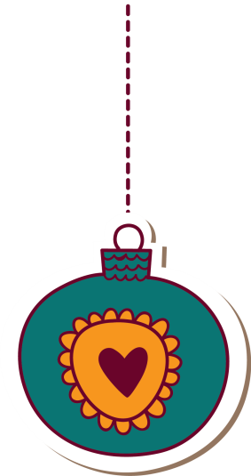



HALFWAY HOME dog rescue

CHRISTMAS COFFEE MORNING!

SUNDAY 1st december 11am -3pm

We will also be having a tombola and bric-a-brac sale.

ALL DOGS WELCOME !!

JOIN US FOR HOMEMADE QUICHE, COFFEE AND CAKES! ALL PROCEEDS WILL GO TOWARDS THE DOGS!